Lab 8-1 Globalizing Siebel Analytics Metadata
Goals | To create initialization blocks and session variables in the Siebel Analytics repository for the locale and externalized metadata string translations.
Scenario | ABC Company management understands that Siebel Analytics as a platform supports globalization, localization, and multilingual functionality. Prior to incorporating data from their recent acquisitions, ABC Company would like a proof-of-concept to be done based on its existing data. You will implement a translation table to translate metadata from English to French.
Time | 25 – 30 minutes
Environment | 
Instructions:
- Create the WC_MSG table, keys and supporting indexes in the ASASupplier2 database. This table will hold the metadata string script translations.
  - In Query Analyzer, select the ASASupplier2 database from the drop-down list.
  - Load the WC_MSG table SQL Script. This script was provided by your database administrator to create the WC_MSG table with the correct schema. In this case, the WC_MSG table matches the schema of the S_MSG table from Siebel Customer Relationship Management (CRM) applications in case ABC Company later wants to incorporate Siebel CRM information into their Analytics database.
    - Select File > Open.
    - In the Open Query File dialog box, navigate to C:\Data\ANADV and select WC_MSG.MSSQL.SQL.
    - Select Query > Execute and verify that the commands completed successfully.
  - Minimize Query Analyzer.
- Import the translation data from the WC_MSG.xls file into the WC_MSG table. This file was created as a proof-of-concept to test the metadata translations. It was created by exporting the metadata strings to populate the MSG_NUM and MSG_TEXT columns. For each row in the resulting WC_MSG table, a duplicate row was created to create the “French” translation of the metadata by prefixing the MSG_TEXT data with the prefix FRA_. In a real implementation, you would translate all the MSG_TEXT fields into French in the duplicate rows. Once the translations had been done, the rest of the columns (such as ROW_ID and LANG_ID) were populated.
  - In Enterprise Manager, expand the ASASupplier2 database and select Tables.
  - Right-click WC_MSG and select All Tasks > Import Data.
  - Click Next in the Import/Export Wizard to define the data source for import.
    - Select the Microsoft Excel 5.0 data source from the drop-down list.
    - Click the ellipsis button, navigate to C:\Data\ANADV, and select
WC_MSG Data.xls.
    - Click Open.
  - Click Next to define the import destination.
    - Verify that Microsoft OLE DB Provider for SQL Server is selected as the Destination.
    - Verify that Server is set to local.
    - Select Use SQL Server Authentication.
    - Enter sa as the user name with no password.
    - Verify that the ASASupplier2 database is selected.
  - Click Next to specify how to copy the data.
  - Select Copy Table(s) and View(s) from the source database.
  - Click Next to specify a destination for the data.
    - In the Destination column, select (ASASupplier2).(dbo).(WC_MSG). Do not select WC_MSG$.
    - Select Preview to verify your definition.
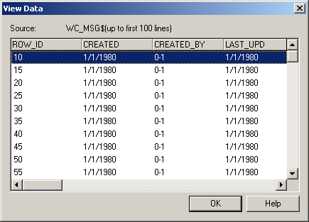
    - Click OK.
  - Click Next.
  - Click Next.
  - Click Finish.
  - Click OK to confirm that the table was successfully copied.
  - How many rows are in the WC_MSG table now?
  - Click Done.
  - Minimize Enterprise Manager.
- Import the WC_MSG table into the Siebel Analytics Physical layer.
  - If necessary, start the Siebel Analytics Administration Tool and open ServArchAdv.rpd in online mode.
  - Select File > Import > from Database.
  - In the Select ODBC Data Source dialog box, select ODBC 3.5 data source connection type.
  - Select the ABC data source.
  - Enter a user name of sa with a blank password.
  - Click OK.
  - In the Import dialog box, expand ASASupplier2 and dbo.
  - Scroll and select WC_MSG so it is highlighted.
  - Verify all check box options are checked in the Import dialog box.
  - Click Import.
  - Click Yes to check out the affected objects.
  - Click Close.
  - Check in the changes.
  - Save the repository.
- Create the external metadata strings initialization block. This initialization block populates the MSG_NUM and MSG_TEXT variables with values from the WC_MSG table, matching the WEBLANGUAGE session variable to the LANG_ID stored in the table. Because the LANG_ID codes are three-character uppercase codes, and the WEBLANGUAGE is a two-character lowercase code, LANG_ID is converted to lowercase and truncated.
  - Select Manage > Variables.
  - In the Variable Manager, select Initialization Blocks.
  - Select Action > New > Initialization Block.
  - In the Initialization Block dialog box, enter ASA Externalize Metadata Strings as the name.
  - Select the check box for Row-wise Initialization to enable it. The Cache Variables check box is automatically checked.
  - Verify that Default is selected for the initialization string and enter the following SQL:
SELECT MSG_NUM, MSG_TEXT
FROM dbo.WC_MSG
WHERE 'VALUEOF(NQ_SESSION.WEBLANGUAGE)' =
SUBSTRING(LOWER(LANG_ID),1,2)
  - Click Browse to choose the connection pool.
  - In the Select Connection Pool dialog box, select the SUPPLIER CP connection pool within the ABC data source.
  - Click Select.
  - Click the Test button to verify the initialization block initializes correctly. The following should be returned:
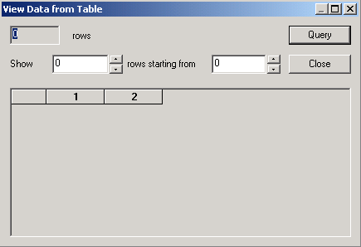
  - Why are no records returned?
  - Click Close.
  - Click OK.
  - Select Action > Close to close the Variable Manager.
- Externalize the metadata names for the SupplierSales Presentation Catalog. This causes the names to be read from the MSG_NUM and MSG_TEXT session variables that are populated by the initialization block.
  - Right-click the SupplierSales Presentation folder and select Externalize Display Names.
Note: Externalize Display Names may already have a grey check mark next to it. This is an effect of the scripted installation process, and does not affect the application. Once you have chosen Externalize Display Names, note that the check mark is now clearly black.
  - Click Yes to check out the objects.
  - Right-click the SupplierSales Presentation folder and select Externalize Descriptions.
  - Check in the changes to the repository and check consistency.
  - Save the repository.
  - Close the Siebel Analytics Administration Tool.
- Log in to Siebel Analytics Web as Administrator in the English language and verify the effect of your configuration in Siebel Answers.
  - Select Start > Programs > Siebel Analytics > Siebel Analytics Web.
  - In the Login screen, enter Administrator with no password
  - Verify that English is selected as the preferred language in the drop-down list.
  - Click Log In.
  - Click Answers.
  - Click Reload Server Metadata to load your configuration changes.
  - Click Refresh Display.
  - From the available subject areas, what do you notice as being different about SupplierSales?
  - Click the SupplierSales subject area.
  - Hover the mouse over the Sales Reps table to bring up a description. What is the description for this table?
  - Hover the mouse over the District column in the Sales Rep table. What is the description for this column?
  - Click the My Account link at the top of the screen.
  - Select français – France for the Locale. The User Interface Language field should update automatically to français.
  - Click Finished.
  - Click the Web Browser Refresh button.
Note: You may be asked to log back in to the application. Just click Log In to re-enter the application.
  - What do you notice about the SupplierSales columns in Answers?
  - Change your user’s Account information back to English – United States.
Solutions 8-1 Globalizing Siebel Analytics Metadata
Answers
2.l. How many rows are in the WC_MSG table now?
460
4.k. Why are no records returned?
No records are returned because we are comparing the transformed LANG_ID to a session variable. Without logging in to Siebel Analytics Web there is no session variable for comparison.
6.h. From the available subject areas, what do you notice as being different about SupplierSales?
SupplierSales is the only subject area to have a description.
6.j. What is the description for this table?
Sales Reps: This is the Sales Reps table description field.
6.k. What is the description for this column?
District: This is the SalesReps table District column description field.
6.p. What do you notice about the SupplierSales tables in Answers?
Most table names are prefixed with FRA_ .
Lab 8-2 Globalizing Charts and Reports
Goals | To develop a custom dashboard and report that may be viewed in another language.
Scenario | ABC Company management understands that Siebel Analytics as a platform supports globalization, localization, and multilingual functionality. Prior to incorporating data from its recent acquisitions, ABC would like a proof-of-concept to be done based on their existing data. You will develop a custom report and translate its labels into French from English.
Time | 15 – 20 minutes
Instructions:
- Create a report in Siebel Analytics Web.
  - If necessary, log into Siebel Analytics Web as Administrator with no password and navigate to the SupplierSales subject area.
  - Create a query with Returns.# of Returns and Customers.Region.
  - Save the request in My Folder as Returns by Region – English.
- Place Returns by Region – English on a Dashboard called Dashboard.
  - Click Dashboards.
  - Click Admin.
  - Click Manage Web Groups and Users.
  - Click Create a new web group.
  - In the Create Web Group screen, enter the following:
Group Name | Report Developers
Password | <None>
Dashboard Name | Dashboard
Dashboard Builder | Student
  - Click Finished. If an AutoComplete dialog box is displayed, click No.
  - Click Finished.
  - Click Manage Analytics Catalog.
  - In the Manage Catalogs screen, click My Folders.
  - Click the Copy/Move icon for for the Returns by Region – English request.
  - Click the Report Developers folder.
  - Select the check box to Move Item.
  - Click Copy/Move Item.
  - Navigate to Shared Folder > Report Developers and verify that the request has been moved.
  - Click Finished.
  - Click Close Window.
  - Refresh the screen through the web browser.
  - Click Dashboard.
  - Select Edit Dashboard from the Page Options drop-down list.
  - Drag and drop a Section onto the Dashboard pane.
  - Navigate to Shared Folders > Report Developers > Returns by Region – English to view the saved request.
  - Drag and drop Returns by Region – English into Section 1.
  - Click Save.
  - Click Log Out and close the browser.
- Stop the Siebel Analytics Web service.
- Stop the Siebel Analytics Server service.
- If necessary, create the folder structure to support globalization in report and dashboard data. This data is stored in files in the <AnalyticsData>\Web\Res directories, in subdirectories corresponding to each language. For example, C:\SiebelAnalyticsData\Web\Res\l_en for English and C:\SiebelAnalyticsData\Web\Res\l_fr for French.
  - In Windows Explorer, navigate to C:\SiebelAnalyticsData\Web\Res.
  - Verify that the C:\SiebelAnalyticsData\Web\Res\l_en\Captions folder exists.
  - Verify that the :\SiebelAnalyticsData\Web\Res\l_fr\Captions folder exists.
- Export the XML from the Siebel Analytics Web Catalog.
  - Select Start > Programs > Siebel Analytics > Siebel Analytics Catalog Manager.
  - Select File > Open.
  - Navigate to C:\SiebelAnalyticsData\Web\Catalog.
  - Open the default.webcat file.
  - Double-click the /.
  - Select Tools > Localization > Export Captions.
  - In the Localization Export dialog box, click Browse.
  - In the Browse dialog box, navigate to C:\SiebelAnalyticsData\Web\Res\l_en\Captions.
  - Click OK.
  - Click OK.
  - Click OK to verify that the export was successful.
  - Select File > Save to save the Web Catalog.
  - Close the Siebel Analytics Catalog Manager.
- Localize the data by translating the text strings from English to “French”.
  - Using Windows Explorer, copy the files located in C:\SiebelAnalyticsData\Web\Res\l_en\Captions to C:\SiebelAnalytics\Data\Web\Res\l_fr\Captions, replacing files as necessary.
  - Use Internet Explorer to open C:\SiebelAnalyticsData\Web\Res\l_fr\Captions\Report DevelopersCaptions.xml (the French version of the captions file for the Report Developers folder you created) to note the tab indents, the levels at which the XML text collapses and expands, and the places where the XML needs to be modified to view the proof of concept dashboard and report in the French language.
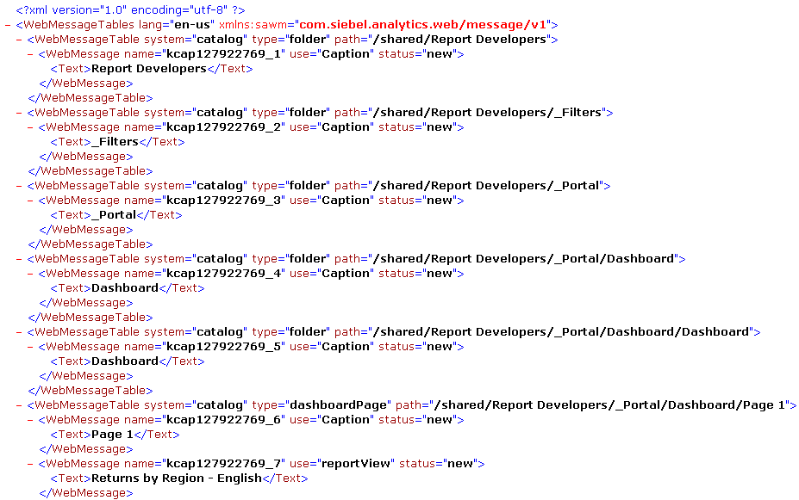Note that it is the strings between the <Text> tags that need to be translated.
  - Close the XML file in Internet Explorer and open the same file in Notepad.
  - Change the language in the lang attribute from en-us to fr.
  - Change the string “Dashboard” in between the <Text> tags to Tableau in two places.
  - Change the string “Returns by Region – English” in between the <Text> tags to Returns by Region – French in two places.
  - Save the file and close Notepad.
  - Open the file in Internet Explorer again to confirm the correct changes were made.
  - Close the XML file.
  - Start the Siebel Analytics Server service.
  - Start the Siebel Analytics Web service. The modifications to the XML will load automatically from their location in the Siebel Analytics Data directory.
- Log in to Siebel Analytics Web as Administrator in the French language to see the difference in the dashboard and report.
  - Select Start > Programs > Siebel Analytics > Siebel Analytics Web.
  - In the Login screen, enter Administrator with no password
  - Select français as the preferred language in the drop-down list.
  - Click Connexion.
  - Upon logging in, what are the names of the available dashboards?
  - Navigate to the dashboard that was created earlier in this lab by clicking Tableau.
  - What is the name of the report that shows up?
  - What has been translated versus not translated in this report?
  - Log out of Siebel Analytics Web and close the browser window.
Solutions 8-2 Globalizing Charts and Reports
Answers
8.e. Upon logging in, what are the names of the available dashboards?
Mon Tableau de bord and Tableau.
8.g. What is the name of the report that shows up?
Returns by Region – French
8.h. What has been translated versus not translated in this report?
The name of the dashboard, report and column names have been translated in this view. The data itself has not been translated.

